Dokumentasi Proyek: MGL - JT.01

Designator: SC-OF-SM-48
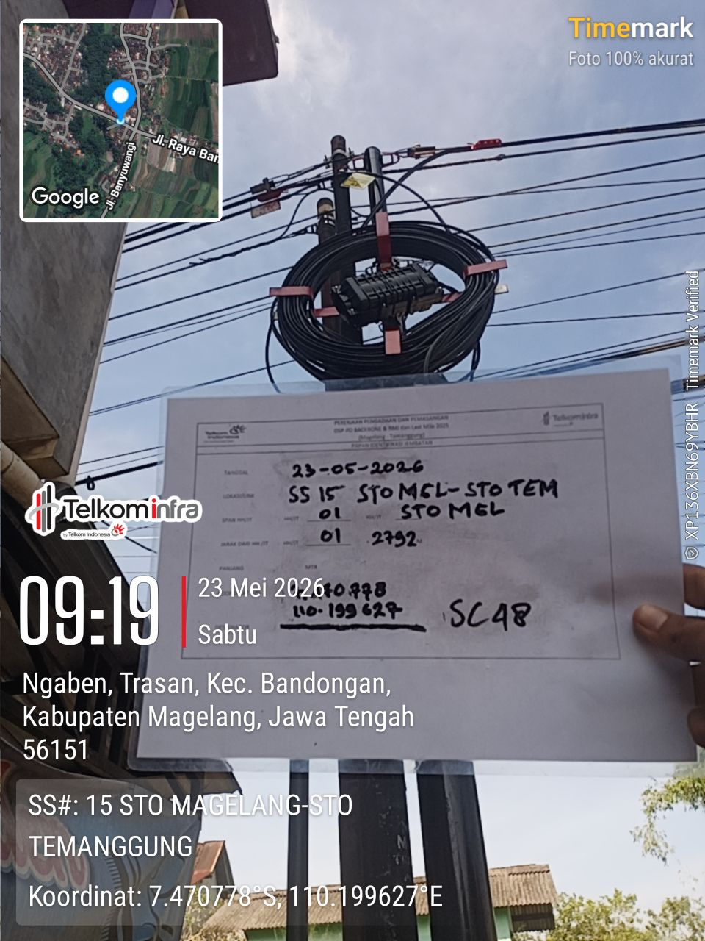 | 